**Tyler Moon**  
*Destiny Bazaan*  
*Cassainy Noel*

2/27/2025

Assignment 10.1

Business Rules and Assumptions:

Winery Operations & Products:

### Bacchus Winery produces four types of wine:

* + Merlot
  + Cabernet
  + Chablis
  + Chardonnay
* The winery grows its own grapes, and Henry Doyle (Production Manager) is responsible for tracking grape harvesting and quality control.  
  **Grape Harvest System tracks:**
  + Grape Type (Merlot, Cabernet, Chablis, Chardonnay)
  + Harvest Date
  + Yield Quantity (tons)
  + Quality Rating
* Wine production uses grapes from the harvest and requires additional supplies, which are sourced from external suppliers.
* Inventory includes harvested grapes, processed wine, and necessary supplies, with quantities tracked for production planning.
* The winery maintains an inventory of harvested grapes, processed wine, and necessary supplies.
* Dates for deliveries of supplies and components cannot be empty, replace with processing date.

### Employees & Departments:

* + **Finance**: Janet Collins (Payroll & financial oversight)
  + **Marketing**: Roz Murphy (Head), Bob Ulrich (Assistant)
  + **Production**: Henry Doyle (Manages 20 production employees)
  + **Distribution**: Maria Costanza (Manages shipments & logistics)
* Each employee belongs to one department only.
* Work hours are tracked on a weekly basis for payroll and reporting, with a specific fiscal week identifier.

### Suppliers & Inventory:

* Three suppliers deliver monthly:
  + **Supplier A**: Bottles and corks
  + **Supplier B**: Labels and boxes
  + **Supplier C**: Vats and tubing
* Inventory must be tracked to ensure sufficient supplies for production.
* Suppliers deliver monthly and are tracked for on-time delivery.
* Supplier performance is monitored, with reports tracking expected vs. actual delivery dates.

### Wine Sales & Distribution:

* Wine production results in finished wine that is stored in inventory until shipped to distributors.
* Distributors place online orders for wine, which are fulfilled based on availability.
* Wine sales are tracked by distributor and type, analyzing:
  + Best-selling wines
  + Top distributors
  + Underperforming wines
* A Wine Sales Report is generated to compare sales trends and improve distributor targeting.
* Wine sales reports track distributor performance based on:
  + Best-selling wines
  + Top distributors
  + Underperforming wines

### Market Research & Pricing Adjustments:

* Marketing gathers feedback from distributors to track customer preferences.
* Finance (Janet) works with Marketing to adjust pricing strategies based on demand and distributor trends.

### Inventory Management

* Inventory tracks stock levels for wine and supplies to ensure sufficient production materials.
* Inventory tracks each wine type.
* The inventory is updated based on wine sales and supplier deliveries.

# Initial ERD Components:

## Entities:

* Employee
* Department
* Wine
* GrapeHarvest
* Supplier
* SupplyOrder
* Distributor
* WineDistribution
* Wine Production
* Supplied Components
* Order
* Delivery
* SalesReport
* Inventory

# Attributes:

## Employee:

* EmployeeID
* Name
* DepartmentID
* WorkWeekHours
* WeekNumber
* Position

## Department:

* DepartmentID
* WeekNumber
* ManagerName
* Name

## Wine:

* WineID
* WineType
* SalesVolume
* InventoryQuantity
* WineName

## Supplier:

* SupplierID
* Name
* ComponentType
* ContactInfo

### GrapeHarvest:

* HarvestID
* GrapeType
* HarvestDate
* YieldQuantity
* QualityRating

### SupplyOrder:

* OrderID
* SupplierID
* OrderDate
* ExpectedDelivery
* ActualDelivery
* Status

## Distributor:

* DistributorID
* Name
* ContactInfo
* Region

## WineDistribution:

* DistributionID
* WineID
* DistributorID
* Quantity
* DateShipped

## SuppliedComponents:

* SupplyID
* SupplyOrderID
* SupplierID
* ComponentName
* QuantitySupplied
* DateSupplied

## WineProduction:

* ProductionID
* HarvestID
* WineID
* QuantityProduced
* ProductionDate

## Order:

* OrderID
* DistributorID
* OrderDate
* ShipDate
* Status

## Delivery:

* DeliveryID
* OrderID
* ExpectedDate
* ActualDate
* Status

## SalesReport:

* ReportID
* WineID
* SalesVolume
* Date

## Inventory:

* InventoryID
* SupplyID
* WineID
* QuantityInStock

# Initial ERD:

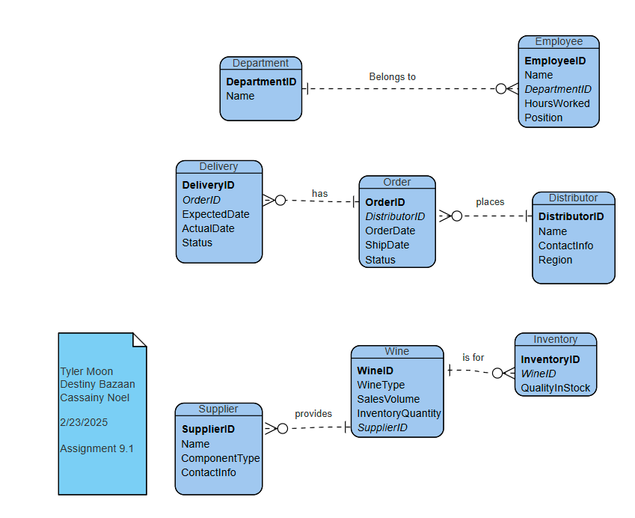

Updated ERD: 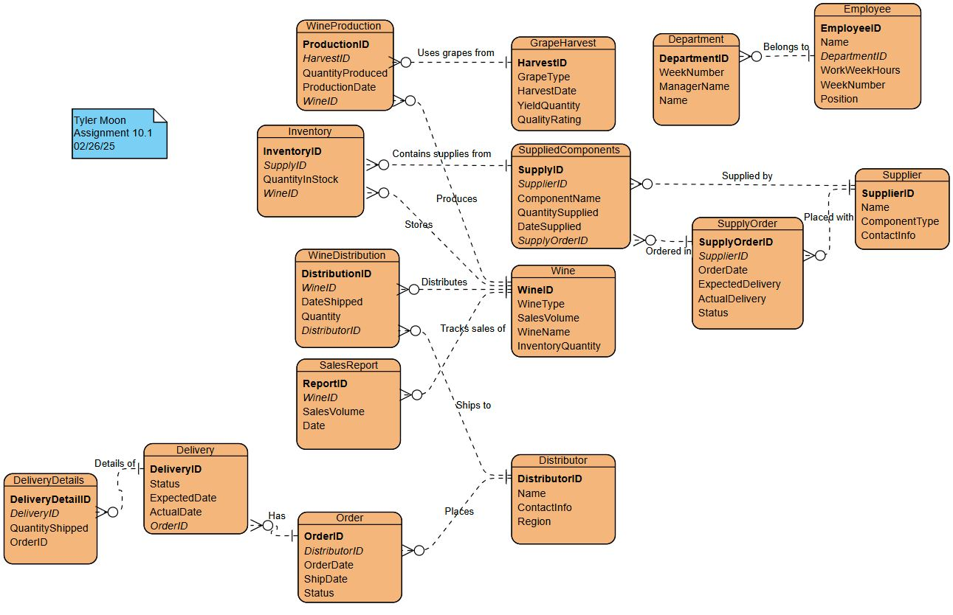

Python Output:

